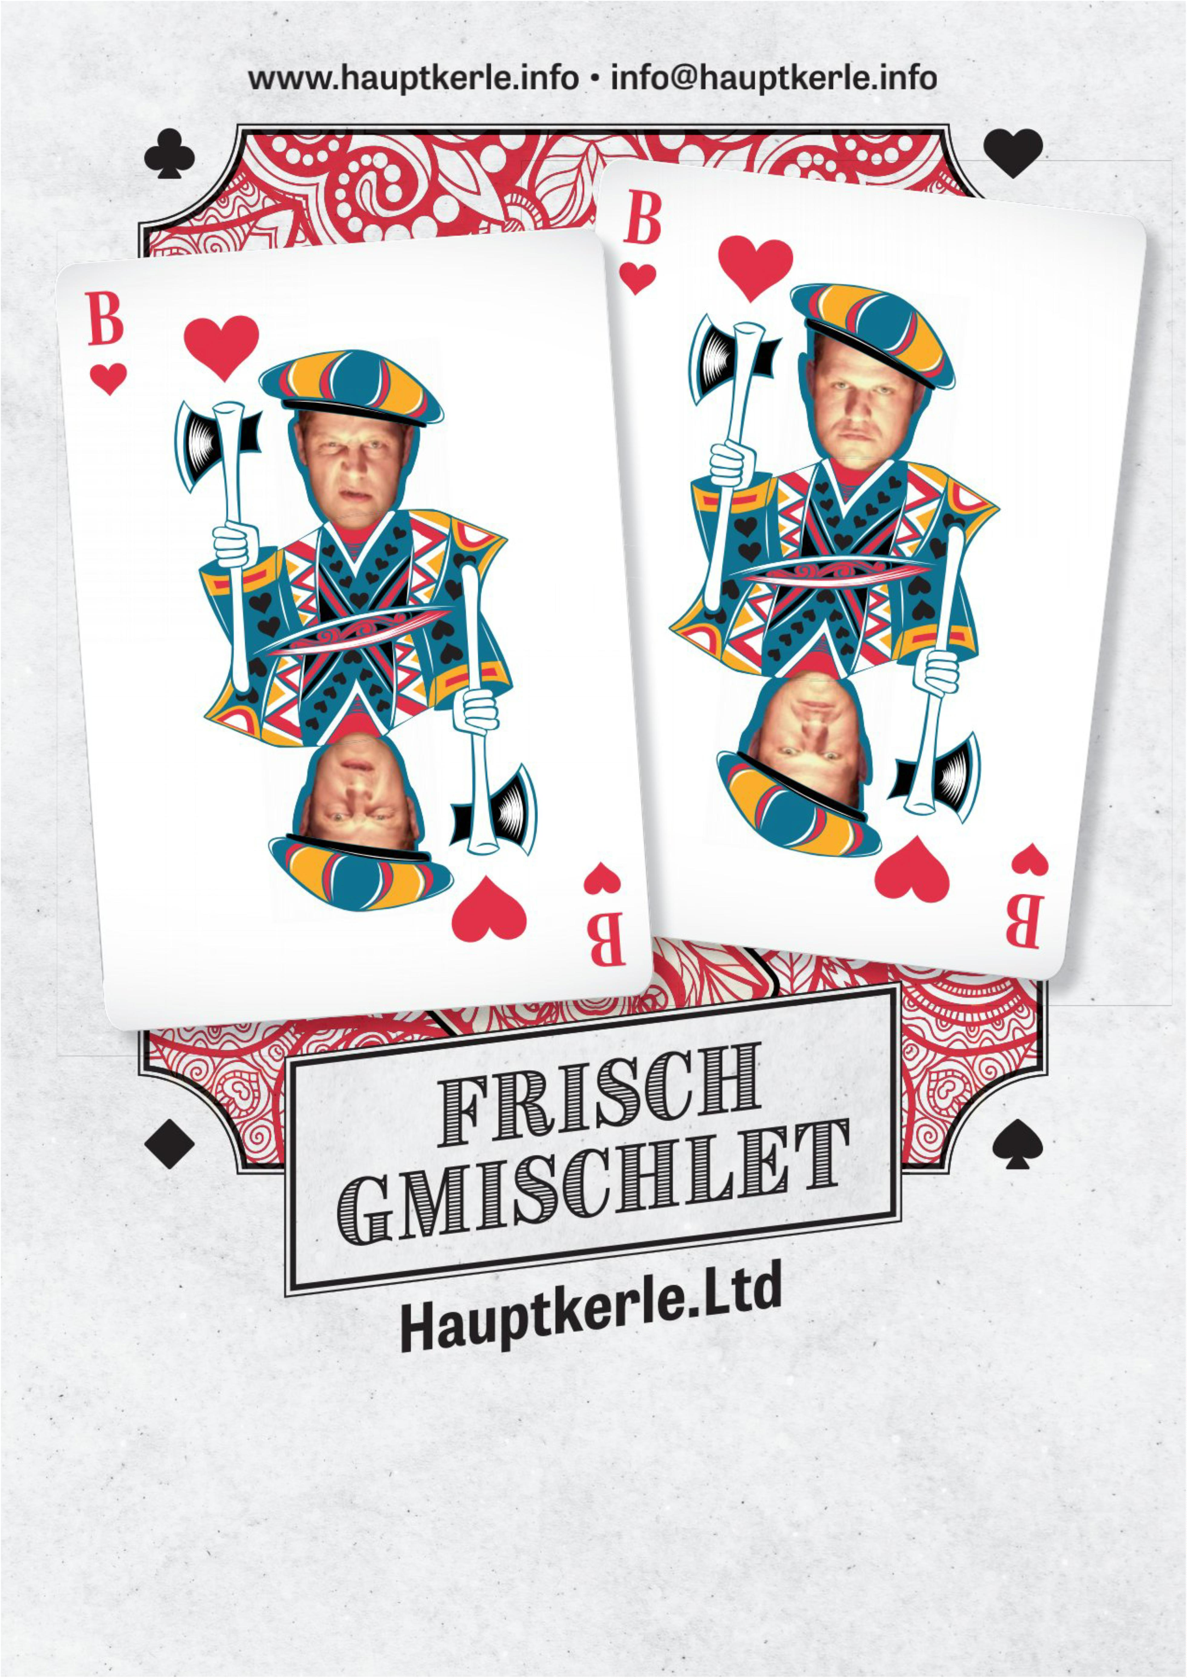ooxWord://word/media/image1.jpeg